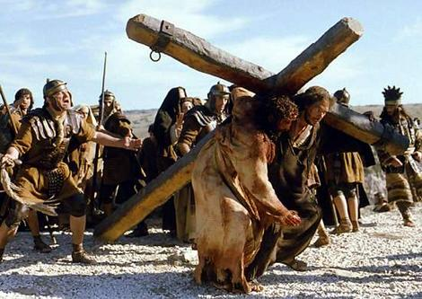
His Cross, My Cross

O My Savior,
I thank you from the depths of my being
for Your wondrous grace and love
in bearing my sin in Your own body on the tree.

May Your cross be to me
as the tree that sweetens my bitter Marahs,
as the priestly rod that blossoms with life and beauty,
as the bronze serpent on the pole that calls forth the look of faith.

By Your cross crucify my every sin.
Make it the ground of all my comfort,
the sum of all Your gospel promises,
the very essence of my religion,
and by it give me that rest without need of rest.

O my Lord and Savior,
You have also appointed a cross for me to take up and carry,
a cross before You give me a crown.
You have appointed it to be my destiny,
but self-love hates it,
worldly reason is unreconciled to it;
without the grace of patience I cannot bear it,
walk with it,
or profit by it.

O blessed cross, what mercies do you bring with you!
You are only esteemed hateful by my rebel will,
heavy because I shirk your load.

Teach me, gracious Lord and Savior,
that with my cross You send promised grace
so that I may bear it patiently,
that my cross is Your yoke that is easy,
and Your burden that is light.

− The Valley of Vision, p. 170.

